**"Native American"**

**Patch**

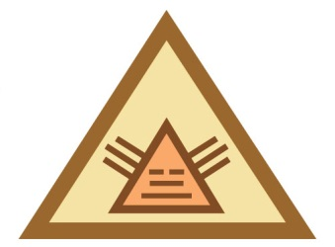**For Girl Scout Brownies**

*The design is a stylized representation of the Plains Native Americans'*

*"Star of Guidance," which was painted on the American Native American's wigwams, horses, and robes to guide their way across the prairie.*

The term “Native Americans” is not used by all decedents of the Americas. Some of the native peoples use the term American Indian Native American or Indian. We realize that each tribe or group of peoples have different views on these terms. With respect to the different views, opinions and definitions, we have chosen to use the term “Native American”. We recommend that participants research the preferences of their research group or neighbor Native Americans and use their preferred term when referring to their cultural group.

It is important that participants constantly remind themselves of the sacred trust we carry when learning about another culture. Especially an ancient culture whose meaning could be easily lost in these modern times. We do not study a culture to belittle what it holds sacred. As Girl Scouts, we believe there is something to be learned from every culture. We believe our strength is in our diversity. We also recognize that stereotypes can only be broken by knowledge and experience. That is why Girl Scouts encourages our membership to reach out to their communities and tap into the diversity with programs like these. We learn about other cultures and their history to enrich our lives and grow stronger through understanding. Native Americans were the very first Americans. There are many different kinds of Native Americans. In the past, their lives were very different than they are today. Try these activities to see how Native Americans used to live.

**Choose four activities:**

1. **Listen to stories.** Ask your librarian for stories about Native American heroes or Native American legends and folk tales. Some of them may be on tape or CD. (Stories are also available at the Balboa Resource Center). Read or listen to **two** different ones. Then draw pictures about the stories and share your pictures with others.

**OR**

Make up a skit, pantomime, or story about a Native American hero or a Native American legend.

1. **Play Native American games.** Learn a game that originated with the Native Americans. Many ball and tag games were played by Native Americans and are much the same today. (See examples in appendix.)
2. **Learn about the Native American’s History.** Visit a museum, Native American cultural center, or other display on Native American life. See the appendix for suggestions. Then, do the following:

                  a.   Look for information on the types of clothing they used to wear.

b.   Notice the types of shelters the Native Americans built and the tools they used.

c.   What kind of things did they make that we consider to be art? Did they make it for another purpose?

1. **Cook and eat traditional Native American food.** Many popular foods of today come from Native American sources. Native Americans were the first to barbecue; steam lobster; and make spoon bread, cranberry sauce, mincemeat pie, popcorn, and baked beans. Until they came to America, Europeans had never seen pumpkins, squash, gourds, peppers, beans, maple sugar, peanuts, chocolate, chewing gum, tomatoes, sweet potatoes, avocadoes, or corn. Try one of the Native American recipes in the appendix.
2. **Make an Native American craft.** Native Americans crafted blankets, pottery, jewelry, beadwork, paintings, carvings, and leatherwork for use in their daily lives. Learn how to make a simple version of one of these items and know how you could use it. See appendix for illustrations.
3. **Create a dance like the Native Americans.** Native Americans dance to celebrate many events in their daily lives. They use dances as prayers, to celebrate happy occasions, to remember special events and to teach the young people of the tribe the stories of their people. Practice a simple Native American-style dance with your group. (See appendix)

**Appendix**

This appendix gives you some activities that can be used while working on this Try-It.  At the end of the packet you will find additional resources that will help you find other sources for materials to complete the Try-It.

* **Games**

1. **Hands and Bones**

"Hands and Bones" is a Blackfoot game similar to "Button, Button". You will need two to 12 players and two "bones", one black and one white (buttons will do).

Players are divided into two teams and sit down facing each other in a line. The first person in one line has a white "bone" in one hand and a black "bone" in the other.

She switches the "bones" back and forth while swaying her body to confuse the team watching her. When she stops her motion, the other team tries to guess which hand has the black "bone". If they are correct, the bones pass to the first person in line on their team. If they are wrong, the "bones" are passed to the second player on the original team.

1. **Ring**

"Ring" is a Navajo Tribe game played with a ring about four inches in diameter. The Navajo Tribe made their own rings by wrapping green yucca leaves around yucca twigs formed into a ring. You can make your own rings by wrapping cornhusks around rope or twig core. Bind rope or twig ends together with string. In any case, the rings should be half green and half white.

Two stakes are put into the ground up to 15 feet apart. The players pitch the rings in turn, standing by one peg and trying to put the ring close to, or over the other peg.

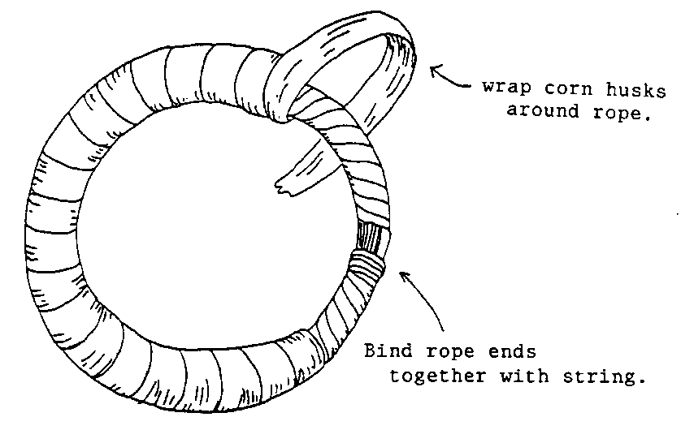If the ring falls with the white side touching the peg, one point is awarded; if the green side touches, two more points are awarded; five points are given for ringing the peg. Ten (or more if there are more players) points wins the game.

1. **Snatching Places**

"Snatching Places" is played by Native Americans of the Northern Plain and is similar to "Musical Chairs". The players form a ring, each on her own blanket, about two feet apart. One player without a blanket stands in the center.

The others constantly change places, while the one in the center tries to step into a place left vacant for a moment. When she succeeds, the player displaced must stand in the center until she is able to find a vacant place.

1. **Catch the Bag**

The Eskimo boys and girls play this game with something that looks like a beanbag but is made of sealskin and filled with sand. The players stand in a circle and toss the bag from one to another. Anyone who fails to catch the bag must leave the circle. The last player remaining wins.

1. **Buzzing Toy**

Some Native American children play with a simple noisemaker that hums or buzzes on a piece of string. A small disc is strung on a cord and the cord twisted to make it spin. As the cord is pulled and loosened, the disc spins faster, humming as it turns. A large coat button can be used and about 20 inches of cord is needed. Pegs or two more buttons can be used on the ends for handles.

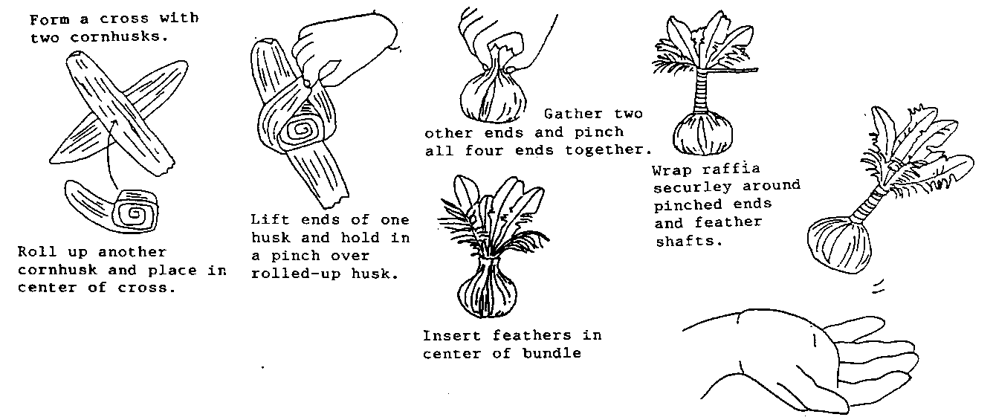

1. **Shuttlecock**

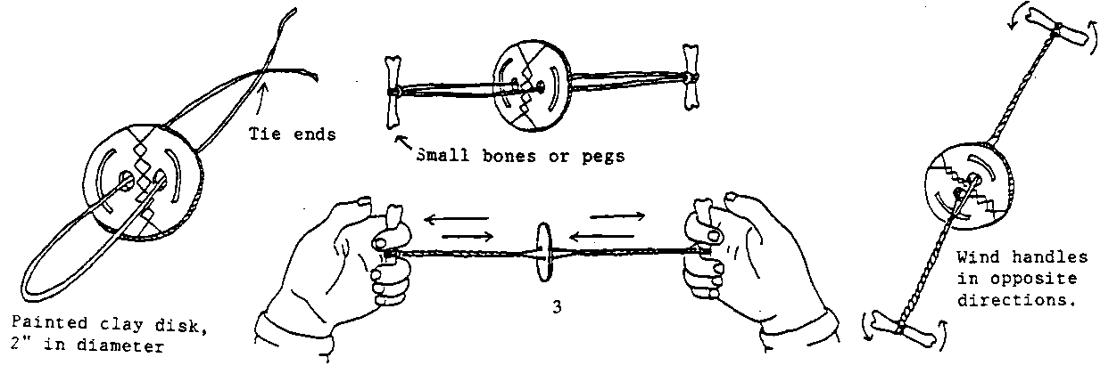Members of the Zunis Tribe invented this game played with a little laced square of cornhusks, decorated with feathers. Players toss it in the air, hitting it with the palm of the hand as many as ten times before passing it to another player.

* **Recipes**

These recipes need adult supervision whenever sharp utensils, hot fat or an oven or stove is used. The starred (*) directions should be done only by an adult.

1. **Native American Fry Bread**

          3 cups                    Flour

          2 tsp             Baking powder

          1 Tblsp                   Shortening

          Salt to taste

                Cooking oil

Work shortening into other ingredients.  Add enough warm water to handle dough easily and work until smooth, soft, and elastic. Use very little extra flour. Form smooth balls the size of lemons.

Brush with shortening and let stand for about 45 minutes. Pat each ball until it is round, flat, and about ¼ inch thick. Poke a hole in the center with your finger in order to let the "chindi" (spirits) out and help the bread to cook evenly.

*Fry in two inches of hot cooking oil until brown on one side. *Turn only once with tongs. *Drain on paper towels. Eat with butter, cinnamon, or fruit spread.

*Recipe from Phoenix Native American School Girl Scout Troop.*

1. **Jerky**

*Have beef, venison, or chicken cut in very thin slices. Then tear into strips with the grain so it will be stringy. Prepare a very strong brine (1 cup water to ½ cup salt) solution. Native Americans used no seasonings, but you may want to add Worcestershire, teriyaki, barbecue, garlic, soy, or other strong flavors to the salt and water. Soak the meat for 24 hours, stirring occasionally.

Lay strips over a line in the sun or on a rack in an oven at a very low temperature (a pilot light is enough). Let it dry until it is crisp (about 24 hours). Pat off any moisture occasionally with a paper towel.

Store in an airtight container. Jerky may be eaten as a snack or re-hydrated in cooked dishes. It will not spoil.

1. **Roasted Nuts**

Using raw, shelled nuts and salt to taste, place the nuts in a shallow baking pan. *Roast in 300º oven for one hour. *Stir frequently so that nuts brown evenly.

          The Native Americans used many nuts. Hazelnuts, walnuts, filberts, and pinon nuts are native to America.

1. **Missiiagan-Pakwejigan (Sunflower Bannock)**

               3 1/4 cups               Sunflower seeds

              3 1/4 cups               Water

               2 ½ tsp    Salt

               6 Tbsp     Corn flour

               2/3 cup    Corn oil

Put the sunflower seeds, water & salt into a pot, cover & let simmer for 1 1/2 hours. When well cooked, crush the seeds to make a paste. Add the corn flour, 1 tablespoon at a time to thicken. Work with your hands; cool a little. Make small, flat pancakes of approximately 5" diameter.

Heat oil & fry both sides, adding more oil if necessary. Drain well and eat.

1. **Baked Pumpkin**

1 small pumpkin, peeled and cut into cubes   
1 cup sugar   
1 teaspoon salt   
Cinnamon

Place pumpkin cubes in a baking dish and sprinkle with sugar and salt. Cover pan with foil and bake in 325º degree oven until soft. Sprinkle with cinnamon.

* **Crafts**
  1. **Pottery**

Make a simple pot using the coil method (see illustration) and decorate it. If you use real clay, have it fired if you can or use oven-baked clay and fire it yourself with the help of an adult. Decorate it in one of the three ways illustrated. Follow package or recipe directions for type of paint to be used if you chose to decorate the pot in this manner.

1. Description:  **Beadwork**

Using large beads, thread onto a string to make a necklace, bracelet, or a decoration for an article of clothing. Older girls can use small beads and wire to make more complicated patterns (see illustration).

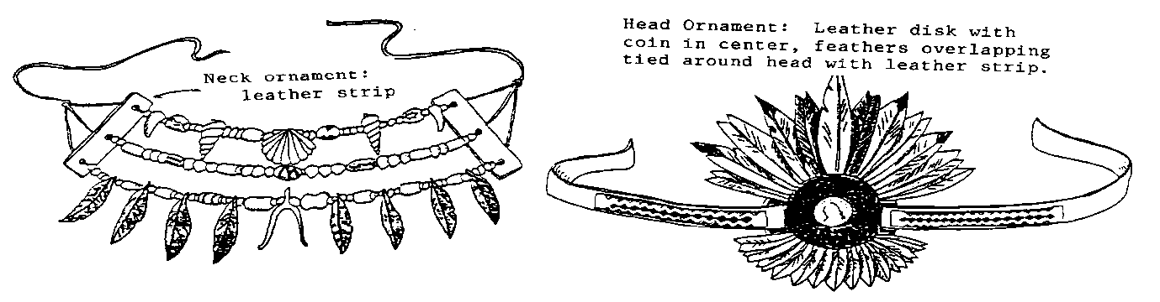

1. **Painting**

Using stage make-up or watercolors and brushes, paint an Native American design on your face or body. Be careful not to paint too close to your eyes and mouth. When you are finished remove paint carefully, following directions on the container. Learn what the signs mean and put them together carefully. Some signs used by several Native American groups are:

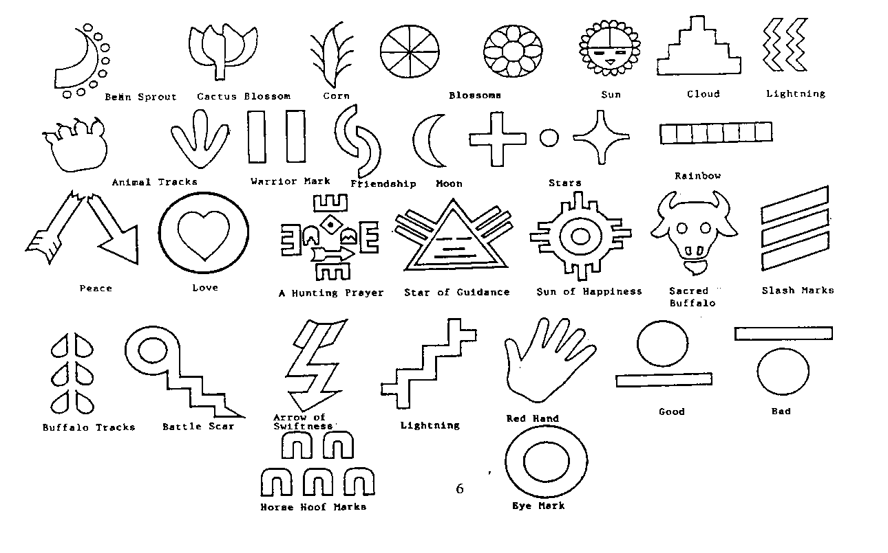

1. **Native American Drum**

With a buddy, make a drum for Native American dancing. You will need a large empty can or canister. Remove both ends. (The Native Americans used gourds). Cut two circles of leather or vinyl that are one inch larger than the ends of the can. Punch holes around the edge of each circle. A leather punch or a paper punch for vinyl can be used to make the holes (adult help may be needed). Put a circle at each end of your "drum". Lace the circles together while your buddy holds the "drum”.

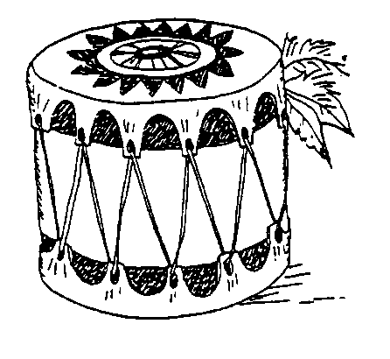

* **Native American Dance**

Several Native American groups consider their dances sacred. The following is a small “building block” of a dance. It will give the participants a taste of the rhythm most Native American dances evoke. The basic step is easy:  Put your toe down with your weight on it; then put your heel down. Shift your weight to the other foot and repeat the toe-heel step in a regular rhythm. You can use rattles or bells to make it more fun and bend far forward or stand straight for variety. Dances are very meaningful aspects of Native American cultures; your performance should express respect.

**Resource Center at the Balboa Service Center**

*Keepers of the Earth* - an audiotape of 25 Native American legends which center upon one of the most important considerations in human experience, the relationship between people and the environment.

*Native American Animal Stories* - a storybook coming from Mohawk, Hopi, Yaqui, Haidi, and other cultures demonstrating the power of animals in Native American traditions.

*The Three Sisters* - understanding Iroquois gardening methods brings a new understanding of Native American culture.

**Museums**

*Barona Cultural Center and Museum* ([www.baronamuseum.org](http://www.baronamuseum.org))

The tribal museum has over 2000 artifacts, listening alcoves and dioramas. Admissions free ~ call to schedule tour.

*Heritage of the Americas Museum (*[www.cuyamaca.edu/museum/](http://www.cuyamaca.edu/museum/) ~ (619) 670-5194)

Cuyamaca College cultural and education center featuring pre historic and historic art, culture and natural history of the Americans. Call ahead for hours.

*Museum of Man, Balboa Park, San Diego* ([www.museumofman.org](http://www.museumofman.org/) ~ (619) 239-2001)

This facility has changing exhibits and permanent displays on a broad range of native cultures. Tours are available for groups and classes can be arranged. A lending facility allows you to check out artifacts for use at other locations. Prices of admission vary with the program.

*Pala Indian Reservation* ([www.palatribe.com/programs/cultural-center](http://www.palatribe.com/programs/cultural-center)/ ~ (760) 742-1590)

They have a small but broad based museum. Call ahead for hours and fees. No tours available.

*San Diego State University* ~ the David W. May Indians Artifacts Collection

They regularly schedule activities in this interest area. Contact the Anthropology Department for information. ~ ([www.sandiego.edu/mayindiangallery/](http://www.sandiego.edu/mayindiangallery/))

**Resources**

*Hon-Dah a la Fiesta Cook Book*, printed by Arizona Cactus-Pine Girl Scout Council, Inc.

*Children's Games from Many Lands*, Nina Millen, Compiler, Allen Eitren, Illustrator, N.Y. Friendship Press 1965

*The Gospel of the Redman*, Ernest Thompson Seton, Santa Fe, 1966

*Native American Crafts Workshop*, Bonnie Bernstein and Leigh Blair, Fearon Teacher Aids, Belmont, California

*Plains Indian Coloring Book*, Donna Greenlee, Scottsdale, 1974

*Kachina Doll Coloring Book*, Donna Greenlee, Scottsdale, 1973

*Indian Legends*, "Hunting Horse", Phoenix, 1973

*Hopi and Zuni Kachina Dancers*, Day-Ga-Khle-Chee, Phoenix, 1973

*Grandfather's Original Story:  The Navajo Beginning*, Richard Red Hawk, Sierra Oaks, 1988

*The Popcorn Book*, Tomie de Paola, Scholastic, Inc., New York

**Special thanks to Committee Members:**

*Ellen Tomkins, Chairman*

Leader, council trainer, teacher, degree in Art History with sub-specialty in American Native American Art

*Teri Beier*

Leader, teacher's aide, part Native American

*Linda Griffith*

Leader, public school staff, part Native American

*Debbie Southward*

Leader, public school staff, professional crafter

*Sharron Bound*

Leader, degree in Cultural Anthropology

**Consultants:**  *Micki Soliz*; leader, Cherokee

*Brownie Troop #2091, Junior Troop #592, and #2119, Cadette Troop #2103*

*Barbara Wiggins*; leader, council trainer

                                                                                                                                                                                 RL:cc

                                                                                                                                                            PG-0035W 1/31/14