
Camp Whispering Oaks
4949 Pine Hills Road, Julian, CA 92036

Camping Confirmation Packet
Council Main Line: (619) 298-8391
Property Reservation Desk: (619) 610-0742 Camp Host: (619) 619-0822
Ranger’s Office: (619) 997-0377

In case of an emergency call: 911
Nearest Hospital: Pomerado Hospital, 15615 Pomerado Rd., Poway
(858) 613-4000

ARRIVAL TIME: 3:00PM
DEPARTURE TIME: 2:00PM

We hope you enjoy your camping experience at Camp Whispering Oaks! Your copy of the Reservation Receipt verifies the details of the reservation. Please review it carefully and contact us immediately if there are any questions.

Check in:
Go straight to your cabin when you arrive. Cabins will be unlocked and ready for your arrival. Keys are not issued. The Camp Host will meet you at your cabin to check you in and give you a walkie-talkie to contact them throughout your stay.
Quiet time is 10pm-7am. Please respect our neighbors by adhering to quiet time.

Tent Campers:
Tent Site 1 has a port-a-potty on site. Tent Site 2 uses the bathrooms located near the field. No showers are available unless you can work out a schedule with one of the cabin units.

Cabin Campers:
You may be sharing the program area with other troops living in your unit. Each troop has its own storage cabinet and refrigerator; however the cooking equipment, dishes, cook stoves (sheepherder and propane), tables and benches are shared. Please contact the other troops sharing the unit to cooperate and compromise in planning a successful event for each troop.

Shared Use:
Two weeks prior to your stay, you may request contact information for other groups using the site at the same time. All campers share main campfire, lodge, playground, sports field, basketball court and general campground and trails. In addition, if renting a cabin, troops share, bathroom facilities, unit porch, cooking areas and equipment. You are encouraged to talk with the other group's leaders to discuss schedules, use of shared facilities, and other “ground rules” you may wish to establish together.

Check out:
Please be sure to let the Camp Host know when you plan on leaving. Complete the check-out list and property exit ticket and leave them in your cabin along with your walkie-talkie. All groups renting our properties are required to clean up after themselves prior to checkout. You may be billed for additional cleaning or repair charges.

⇨ Please contact us if you need to cancel or make any changes to your reservation. Your cooperation is appreciated! Refer to Property Resource Guide for refund procedures.

This packet will help you prepare for use of our facilities. Please help the girls understand the importance of respect and responsibility for their council property and equipment. It is through their efforts in the cookie sale and the support of adults through annual giving that these program facilities are available. The property department needs your cooperation to maintain the facilities to Girl Scout high standards.

The following are included in this packet:

- Camp Whispering Oaks Map (PRO-0011)

- Trail Map (PRO-0009) for hiking the Julian properties

- Directions and Road Map (PRO-0007) to Whispering Oaks

- Girl Scout Emergency Support Network (PGO-0044)

- Troop Contact Log (PGO-0033) / Helpful Hints for In Town Contacts (PGO-0153) - to be completed and left with your in-town contact

- Safety Management Plan (PGO-0154) - to help you with pre-trip planning. Share the information with the girls and adults going on the event. Review with the activity consultant if you have questions.

- Check-Out List for Council Properties (PRO-0001) – to help troops “leave it cleaner than you found it”.

- Property Exit Ticket (PRO-0002) – to be completed and returned to Ranger.

Review Property Resource Guide; especially the guidelines and policies, General Safety Regulations and Safety Management Procedures and information about the Whispering Oaks Program Center.

If we can assist you in any way, please do not hesitate to call us at (619) 610-0742. Thank you for providing this program opportunity for girls.

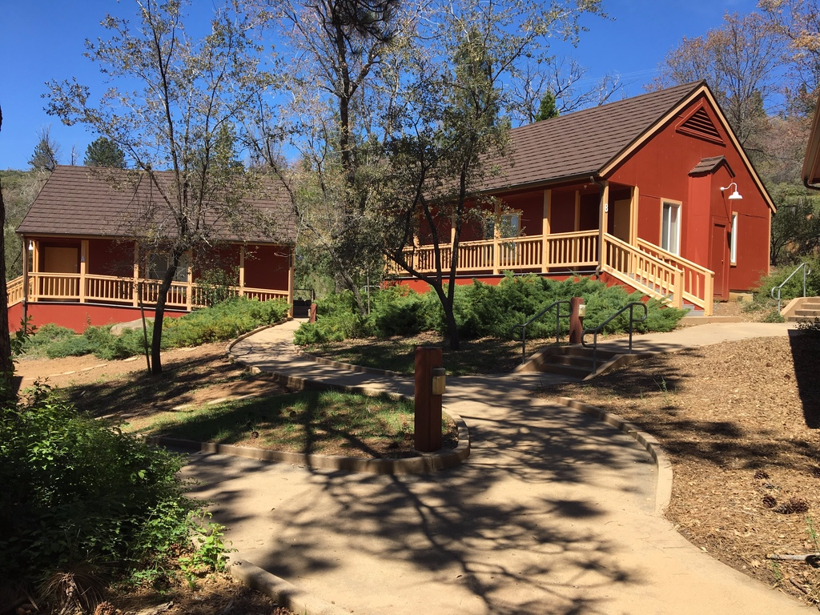

GC:jsr
PGO-0192 4/3/17

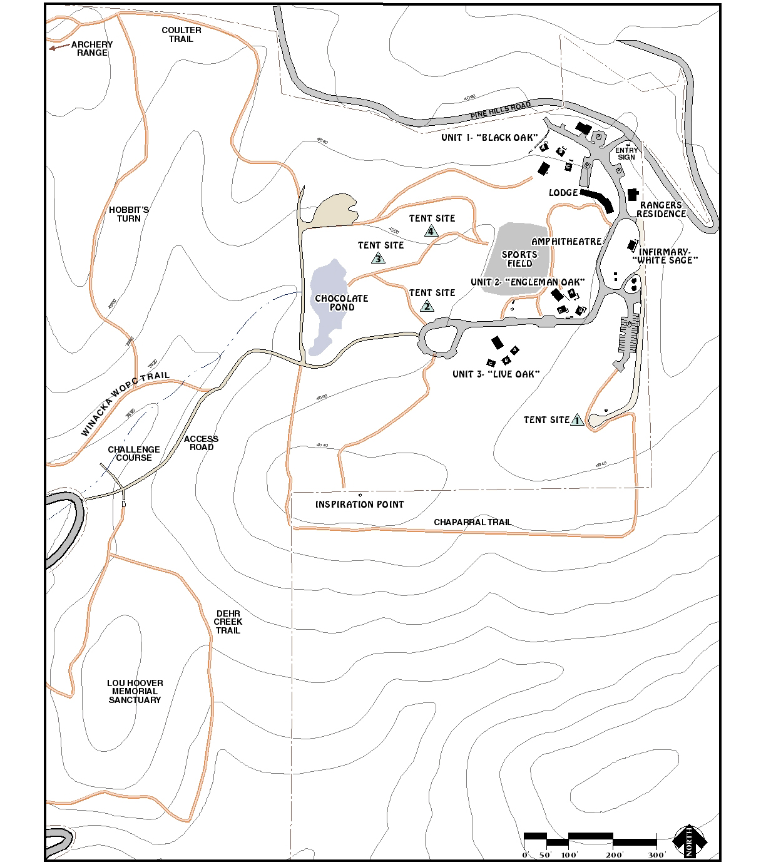
Camp Whispering Oaks

KQ:mlm:jd
PGO-0198- 4/22/10*
Trail Map
Camps Winacka and Whispering Oaks

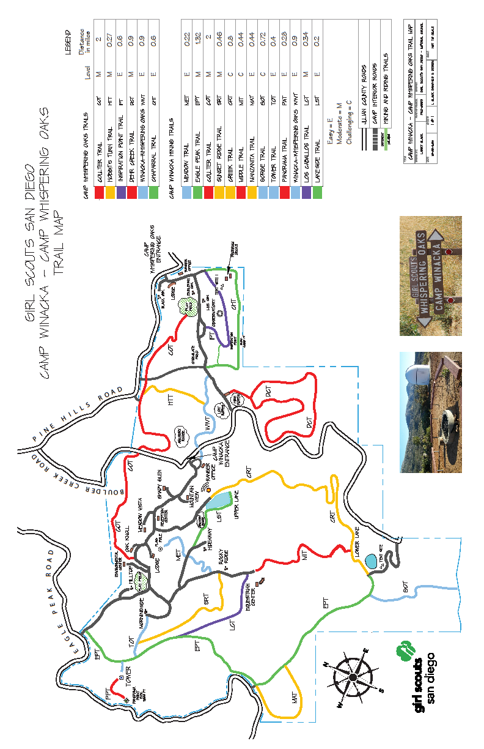
Directions to
Camps Winacka and Whispering Oaks
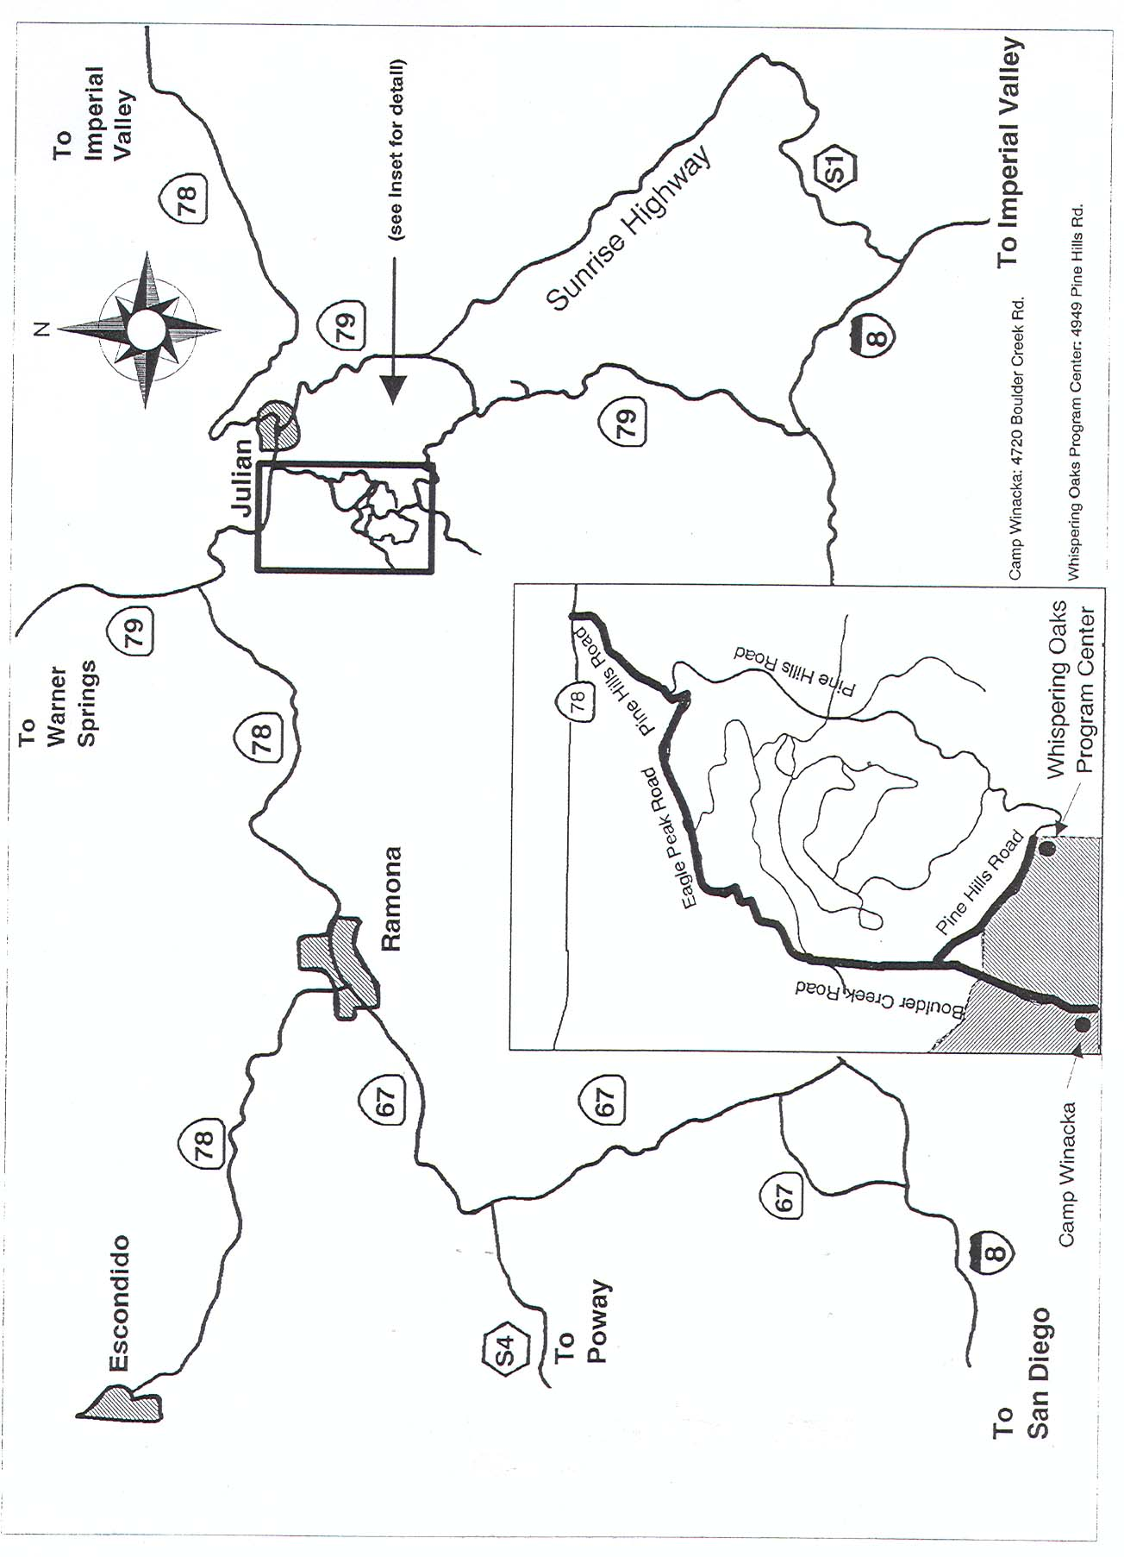
To reach Camp Whispering Oaks:
From highway 78/79 take PINE HILLS RD. turnoff 1 mile west of Julian. Drive 1½ miles; bear RIGHT on EAGLE PEAK RD. Follow EAGLE PEAK RD. 1½ miles to the junction with BOULDER CREEK RD. Go left ¼ mile and bear LEFT on PINE HILLS RD. Continue on PINE HILLS RD. ½ mile to the entrance to Whispering Oaks Program Center on the right.

To reach Camp Winacka:
From highway 78/79 take PINE HILLS RD. turnoff 1 mile west of Julian. Drive 1½ miles; bear RIGHT on EAGLE PEAK RD. Follow EAGLE PEAK RD. 1½ miles to the junction with BOULDER CREEK RD. Go left ¼ mile and bear RIGHT on BOULDER CREEK RD. when it joins PINE HILLS RD. Continue on BOULDER CREEK RD. ½ mile to the entrance to Camp Winacka on the right.

KQ:mlm:jd PGO-0194- 4/22/10*

GIRL SCOUT CAMP

EMERGENCY SUPPORT NETWORK

What is an emergency at camp?
- Life threatening injuries
- Loss of utilities for an extended period of time
- Natural disasters
- Lost or runaway person(s)

When do we evacuate?
Final decisions regarding evacuation are made by the on-site support team or directed by local authorities. Factors may include the following:
- Threat is four hours or less from camp
(This will be affected by environmental and human factors.)
- Resources are diminishing
- Roadways may become restricted or closed

On-Site Support Team
- Local authorities: Sheriff, Fire Department, and California Department of Fire
- Mountain property team
- Event or encampment director, camp host or troop leader
- Assisting leaders
- Campers

Off-Site Support Team
- Program specialist
- Resource assistant
- Council receptionist
- On-call director
- Volunteer support coordinator
- Director or troop leader

MOUNTAIN INFORMATION HOTLINE: 800.643.4798

Preparing for Camp
- Review the contact sheet with your family and post in a central location.
- Encampments: check in with your encampment director with any additional questions.
- Resident camp: check in with the resident camp specialist with any questions.
- Talk to your daughter, your troop and fellow parents about their role and its importance in an emergency.

On-Site Resources
- Emergency Guide with instructions and recommended action steps
- 24-hour radio contact with resident staff members
- Pre-set and mapped evacuation sites
- Cooperative and caring environment of Girl Scouts

Questions?

Contact the Camp Whispering Oaks Director at (619) 298-8391 or campdirector@sdgirlscouts.org

GC:jsr PGO-0044 9/26/16

Helpful Hints for In-town Contacts

Select someone who will remain at the contact phone number during the period of the activity. This person should be provided with the following:

1. A list of all participants including their home phone number and emergency contact name and phone number. (See sample form below.)

2. List of drivers and their vehicle license plate numbers.

3. A list of which girls are being transported in each vehicle.

4. Sample of the permission slip sent home.

5. One of the council's “Major Emergency Procedures” cards.

6. General plan and schedule for the activity.

7. A telephone number where the troop can be reached, or a system for the leader to periodically check in with the in-town contact.

The in-town contact's responsibility is to be the communication link between the troop members and their families. The in-town contact agrees to be home during the time of the event or outing. If there is an emergency or delay, the troop/group leader calls the in-town contact. In turn, the in-town contact will notify the parents. The in-town contact must be an adult and understand the importance of her/his job.

If the troop/group experiences a problem, the adult in charge calls the in-town contact and she/he makes all necessary calls and arrangements.

Sample form:

Troop Contact Log
Date: Leader:
Where troop can be reached:
Expected arrival time:
Place of arrival:
Name | Girl's Home Phone | Emergency Phone | Driver | Permission Slip

GC:mlm
PGO-0153 5/21/13

Troop Contact Log
Provide completed log to In-Town Contact
Date: Leader: Where troop can be reached:
Expected arrival time: Place of arrival:
Name | E-mail | Girl's Home Phone | Emergency Phone | Driver | Permission Slip
SS:mlm
PGO-0033W 5/21/13

Safety Management Plan for Troop Activity

Adult trip leader’s name: _______________________________ Troop number: ___________

Address:___________________________________________________ Phone (day):(_______)_________________
City:_________________________________ Zip:_________________ Phone (eve):(_______)_________________
Number of girls participating: __________ Age level: ________________________________
Number of adult females participating: __________ Number of adult males participating: __________
Council training taken: ___ Let’s Camp ___ Let’s Cook Out ___ Let’s have a Campfire ___ Lets Tent
Activity site: ______________________________________ Address: __________________________________________
Cross street: _____________________________________ Phone # at site: (______)______________________________
Time and date of departure: ____________________ Time and date of return: ____________________
Type of activities planned: ______________________________________________________________________________
___________________________________________________________________________________________________
Name of first aider: _________________________________ Expiration dates: First Aid __________ CPR __________

List all forms of transportation to be used: __________________________________________________________________

Drivers and vehicles to be used:
Driver | Driver’s license  number | Make and model  of vehicle | Vehicle license  number

Emergency Numbers

Site Contact Name: ______________________________ Phone Number: (______)___________________
Fire Department: _CAL FIRE Julian Station_______ ____Phone Number: _911_(760) 765-0511________
Police/Sheriff: _San Diego Sheriff’s Dept. _____________ Phone Number: _911_(760)_765-4718________
Nearest Emergency Medical Facility:Pomerado Hospital Phone Number: _911_(858)_613-4000________
Address: _15615 Pomerado Road _______________ City: _Poway______________________________
In-town Contact: _____________________________ Phone Number: (______)_____________________

Safety Review

In the boxes below indicate the safety points to be reviewed with all participants. Date and initial when done. Tip: Letting girls participate in developing the rules helps them in following those rules.

Means of  transportation | Safety rules to be reviewed prior to departure | Date of  completion

Planned  activities | Safety rules to be reviewed prior to program activity | Date of  completion

Outdoor living | Safety rules to be reviewed | Date of  completion
Cooking

Sanitation

Sleeping

Other

Evacuation plan in case of fire (non-council site): __________________________________
______________________________________________________________________________
______________________________________________________________________________
______________________________________________________________________________
______________________________________________________________________________

Emergency plan in case of a natural disaster (non-council site): ______________________
______________________________________________________________________________
______________________________________________________________________________
______________________________________________________________________________

Site hazards: __________________________________________________________________
______________________________________________________________________________
______________________________________________________________________________
______________________________________________________________________________

Attach list of all participants and carry a copy of this on trip.
Review the information with the girls and adults going on the trip.

Your activity consultant can be a helpful resource person
if you have questions on completing this form.

SS:mlm
PGO-0154W 5/21/13

Check-Out List for Council Properties

In order to ensure that our facilities are indeed “left cleaner than you found it,” please use the checklist below. The buildings have been stocked with cleaning supplies and equipment. Use them as necessary and return them to their proper place. Check out time at all council sites is 2 p.m.

All Buildings
◻ Move all luggage, craft supplies, etc., outside.
◻ Return everything to its original location anything (tables, benches, etc.) you may have moved or taken to another building.
◻ Make sure fire in fireplace is out. Leave coals or ashes in the fireplace. Fires should be extinguished several hours before you leave. Do not use water to put out fire, except in an emergency.
◻ Return unused wood to woodpile and restack neatly.
◻ Place all refuse in the trashcan provided outside the building and secure lids. When outside cans are full, haul bag to the dumpster and replace the can liner.
◻ Sweep all exterior decks and porches. Sweep all interior floors; wipe up any spills with wet sponge or rag. Check bunk beds and other areas for graffiti. Leaders: please check every bunk for graffiti - if previous damage is not recorded on the Property Exit Ticket, your troop or group will be held responsible and will be expected to repair the damage.
◻ Thoroughly clean kitchen area. Empty and wipe out refrigerator; but, leave plugged in and turned on. Make sure doors are securely closed!!! Do not leave any food.
◻ Put dishes and cooking equipment away. Be sure everything is clean and ready for the next group.
◻ Mop all kitchen and bathroom floors. Rinse out mop and bucket.
◻ Clean and scour all sinks, toilets, and showers.
◻ Make sure all faucets and showers are turned off.
◻ Pick up all papers and trash.
◻ Empty sanitary napkin receptacles (white houses) in outside trash cans.
◻ Return chairs and tables to storage closet. Do not drag across floors.
◻ Flip up and store mattresses on edge at mountain properties.
◻ Turn off heaters. If building has thermostat, set at 60 degrees.
◻ Close and lock all windows and doors (if applicable).
◻ Turn out all lights.
◻ After exiting building, walk around outside and double check all doors to make sure they are securely closed! At Camps Winacka and Whispering Oaks leave buildings unlocked.
◻ Complete the Property Exit Ticket form.

Outside Cooksites/Tent Areas
◻ Make sure fire is extinguished in fireplace, camp stove, barbeque or fire circle. Leave coals or ashes. Fires should be extinguished several hours before you leave, unless it is an emergency. Do not use water to put out fires in fireplaces, camp sheepherder stoves or barbeques.
◻ Be sure stove door or barbeque lid is tightly closed and damper is shut.
◻ Return all unused wood to the woodpile and restack neatly.
◻ Pick up all paper and trash, and place in trashcans. Be sure lids are secured.
◻ Rake the area, pick up and dispose of refuse, and return rakes.
◻ Wash off tables.
◻ Take down dunk bags and remove clotheslines you put up.
◻ Complete Property Exit Ticket.

Your final steps!

At Camp Whispering Oaks - leave the buildings open. Leave the Exit Ticket and walkie-talkie in your cabin and the Camp Host will come around to collect it.

GC:jd
PGO-0188- 4/25/16
Property Exit Ticket

Whispering Oaks: ◻ Black Oak ◻ Engleman Oak ◻ Live Oak Cabin used _____________

Turn in this completed form when you check out. The information is used by the rangers to prepare the site for the next group. Your help in having the site ready for future girls to enjoy is appreciated. Practice the Girl Scout Law, “I will do my best to make the world a better place and be a sister to every Girl Scout….”

If archery equipment was used, turn in the appropriate inventory/evaluation sheet(s) with the keys.

Group Attendance Report
Complete the following to assist the council in maintaining accurate property records. Thanks for your cooperation.

Dates of event____________ Troop number ________ Age level ______ Service unit _____________
Number of non-registered members adults ________ children __________________
# of registered girls _______ # of registered adults ________ # of males _______Total ____________
Leader’s name _________________________________ Phone number (_______)________________

Equipment/Property Damage Report
To assist our efforts in keeping your property and equipment in a safe and well-maintained condition, we ask that you please take the time to complete this form. Please circle and fill in your response. Thank you!

1. In what condition did you find the facility? excellent good fair poor
2. Is there any damage to report? no yes
3. If yes, what is the nature of the damage? (Use back of sheet if needed.)
______________________________________________________________________________________________________________________________________________________________________
4. Do you know how it was caused? ______________________________________________________________________________________________________________________________________________________________
5. Additional comments or recommendations? _________________________________________________________________________________________________________________________________________________________________________________________________________________________________________________________6. What part of the property or property service did your troop/group enjoy the most?_________________________________________________________________________________________________________________________________________________________________

GC:jd
PGO-0189 8/3/17

